**Problem 1 [just for fun!] – NO CREDIT**

**a) SARIMA(2,1,0)(1,1,0)[4]**

ANSWER:

(1-B4) (1- Φ1B4)(1-φ1B- φ2B) (1-B)Xt = at

**b) SARIMA(1,0,1)(0,0,1)[12]**

ANSWER:

(1-φ1B) Xt =(1-θ1B)(1-Θ1B12) at

**c) SARIMA(0,1,3)(0,1,1)[4]**

ANSWER:

(1-B4)(1-B)Xt = (1- θ1B - θ2B - θ3B) (1- Θ1B4) at

**Problem 2 [15 pts]**

**a) Analyze the distribution of the quarterly earnings. Are the data normally distributed? Provide appropriate statistics, tests and graphs to support your conclusions.**

ANSWER:

Clearly, it is not normally distributed from the results below,

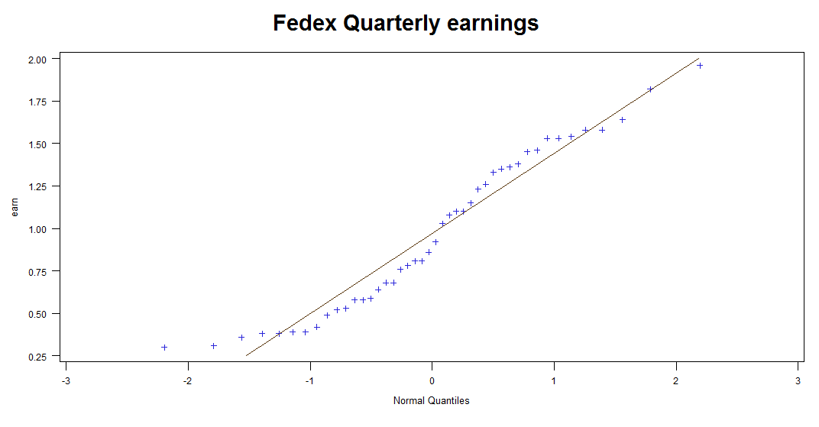

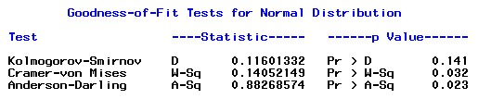

K-S test accepts the null hypo that it is normally distributed.

**b) Is there any evidence of a seasonal effect in the data? Explain your answer.**

ANSWER:

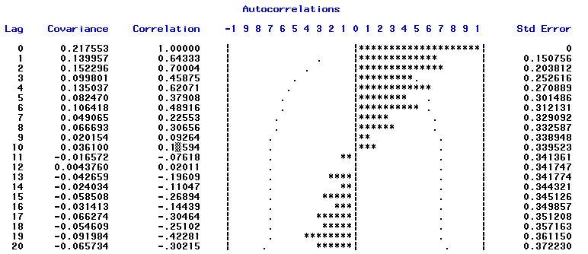

Given there are around 40 obs in the data, we could see that the ACF decays very slow. Therefore, it shows signs of seasonal effect.

**c) Is the quarterly earnings time series stationary? Provide statistics, or graphs to support your conclusions.**

ANSWER:

It is not stationary, given that ACF does not converge to zero and the plot below, which shows that variance and mean are not time invariant.

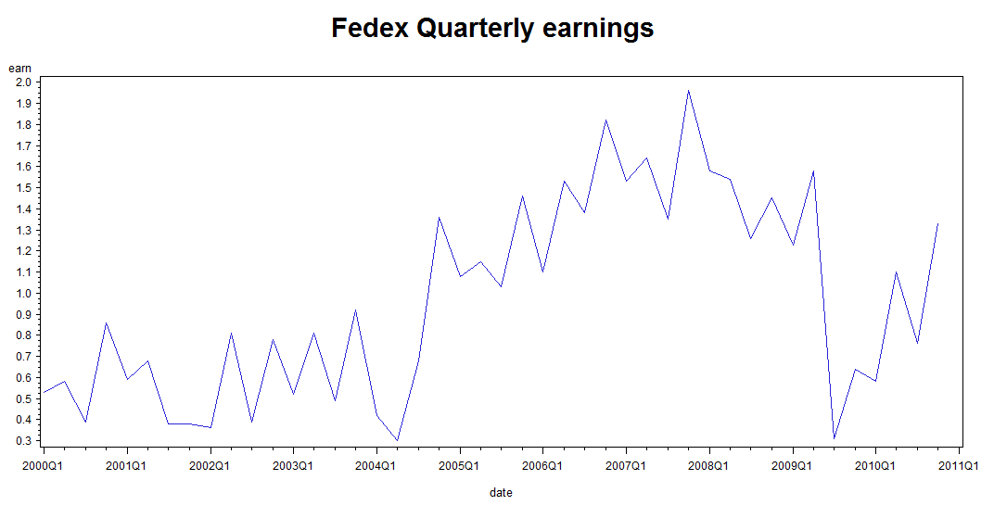

**d) Compute the Dickey-Fuller test for the quarterly earnings for p=1, 3, and 5. Write down the test hypothesis, and the test statistics and analyze the results of the test.**

ANSWER:

D-F test: H0: Φ1=1, H1: Φ1 < 1.

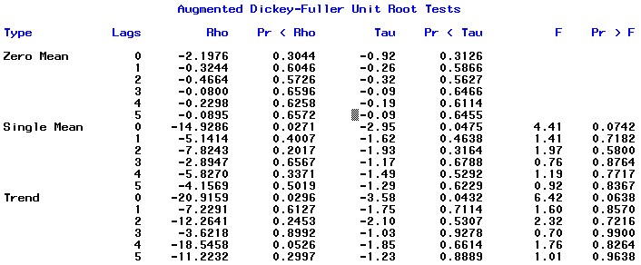

For our analysis, I assume we do not know the real mean for earnings, thus using Single mean (although P-value of Tau concludes that null hypothesis is denied in all cases). P-value of Tau are larger than critical value for p =1, 3, 5, saying that possibly the AR (p) with p = 1, 3, 5 are unit-root.

**e) Take the first difference of the Fedex earnings, and analyze its autocorrelation function. Is the differenced time series stationary?**

ANSWER:

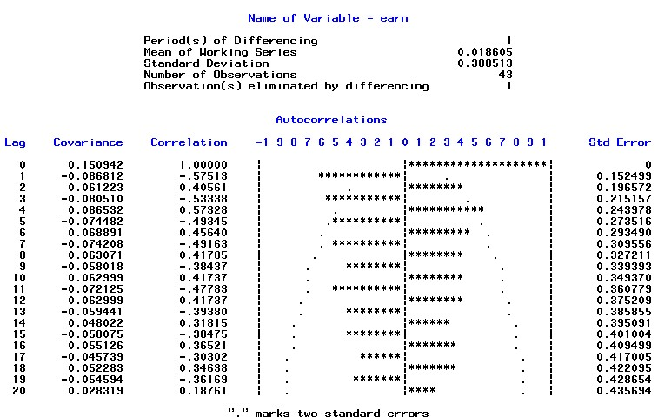

This ACF function is a classical seasonal time series. Clearly, it is not stationary.

**f) Is you de-trend and de-seasonalize the fedex quarterly earnings, do you obtain a stationary time series?**

ANSWER:

(I Suppose your question is: IF you de-seasonalize the time series, do you obtain a stationary time series?)

If we adjust the seasonal effect, say periods=2, we could get the ACF that behaves like a stationary series. Also, D-F test also shows that the estimated model does not have unit root.

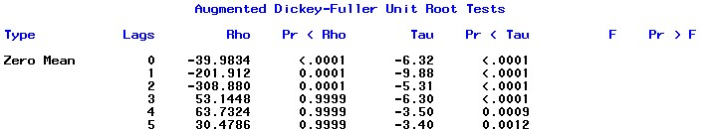

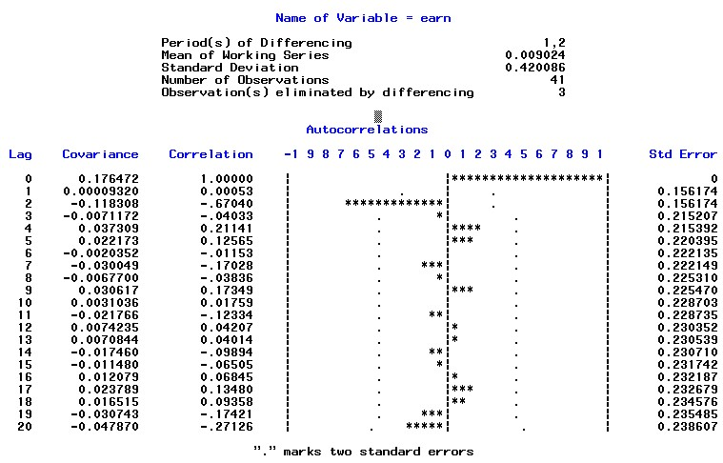

**g) Apply an airline model SARIMA(0,1,1)(0,1,1)4 to estimate the Fedex quarterly earnings.**

**a. Write down the estimated expression of the fitted model**

**b. Are all model coefficients significant?**

**c. Analyze the residuals to check the model validity**

ANSWER:

a. (1-B)(1-B4) Xt = (1- θ1B)(1- Θ1B4)at .

b. Nop. See below, MA1,1, θ1 of the above, is not significant.

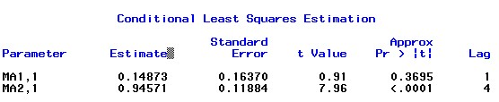

c.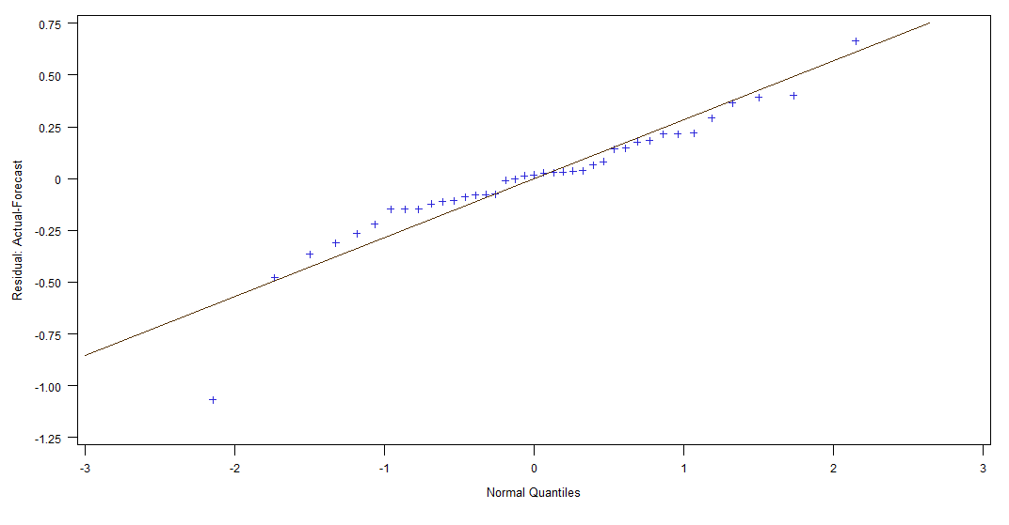

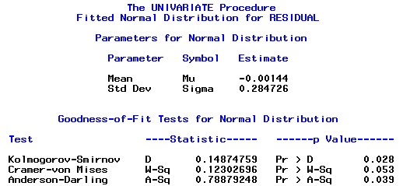

From the results, we could see that both QQ plot of and K-S test for residuals say that the residuals are not normally distributed. Therefore, maybe it is not a good model.

**h) Apply a seasonal model SARIMA(0,1,0)(0,1,1)4 with no MA(1) regular component to estimate the Fedex quarterly earnings. (If you are not sure how to do this, post a message on the discussion forum – I’ll give you some help!)**

**a. Write down the estimated expression of the fitted model**

ANSWER:

(1-B)(1-B4) Xt= (1- Θ1B4)at.

**b. Are all model coefficients significant?**

ANSWER:

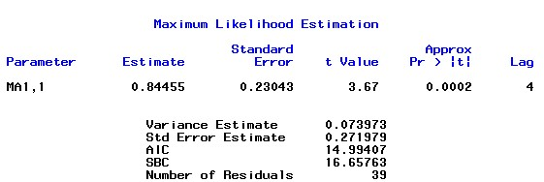

There is only one coefficient and it is significant. Notice it is Maximum Likelihood estimation.

**c. Analyze the residuals to check the model validity**

ANSWER:

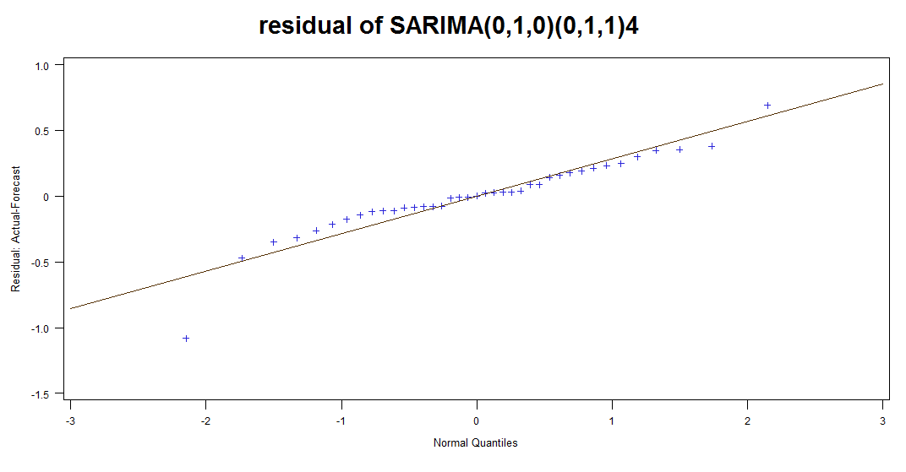

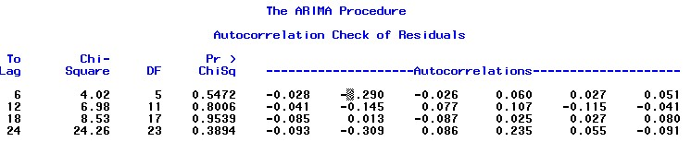

Notice that although QQ plot looks no improvement, the K-S test has a p-value that is slightly higher than 5%, which is the minimum line for conclusion of normal distribution. Also, the L-B test shows that we could not reject that there is no correlations among residuals. In sum, this model is better than the previous.



**i) Which model is a better fit for the data? Explain what evidence you use to select the best model.**

ANSWER:

Like said before, the second, **SARIMA(0,1,0)(0,1,1)4,** is better than the first in light of its residuals, which are not correlated as the first one does. What`s more, the extra coefficient added is not significant, so seemingly we do not need to add it. Thus, the second one is my choice.

**j) Compute forecasts for Fedex quarterly earnings for the next 4 quarters (2011Q1-Q4) using the selected model.**

ANSWER:

C:\Users\felix\Dropbox\courses\csc 425\homework_4\9999.jpg

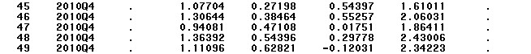

Forecasted earnings for next consecutive four periods are 1.077, 1.306, 0.941 and 1.364.

**k) The released quarterly earnings for Fedex in the first two quarters of the 2011 fiscal year are as follows: 2011Q1: $1.20, 2011Q2: $0.89. Compare the forecasts of your selected model with the actual earnings. Do the prediction intervals contain the actual values?**

ANSWER:

The 95% range for next two earnings are [0.544,1.610] and [.553, 2.060], respectively. The real earnings are within the forecasted range. The last actual earning included in the data is 1.33 (2010Q4), saying that the upper bound for its increase is smaller than its lower bound for decrease.

**Problem 3 [10 pts]**

**1. Is there evidence of serial correlations in the log returns? Use autocorrelations and 5% significance level to answer the question.**

ANSWER:

From the result, we could infer that the serial correlations are relatively weak, though I could not say there is no relation.

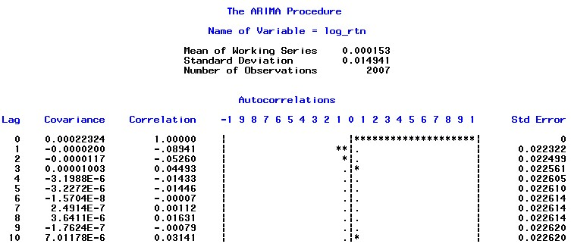

**2. If there is serial correlation in the log returns, fit an appropriate AR model.**

ANSWER:

The PACF function shows that correlations are significant for P=3. So I would start from AR(3) model.

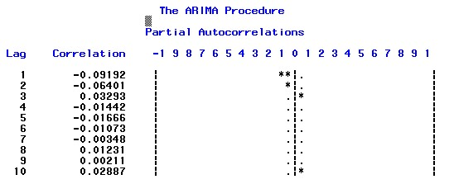

For AR(3),

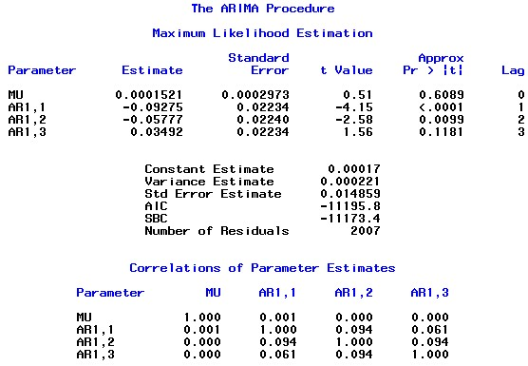

The model is rt = 0.00017-0.09275rt-1-0.05777rt-2 +0.03492rt-3

**3. Is there evidence of ARCH effects in the log returns? Use appropriate tests at 5% significance level to answer this question.**

ANSWER:

In order to detect ARCH effect, we should check the squared returns (first pcitrue) and absolute return (second picture below) ACF`s functions. Both of them show strong correlation, indicating that they have ARCH effect.

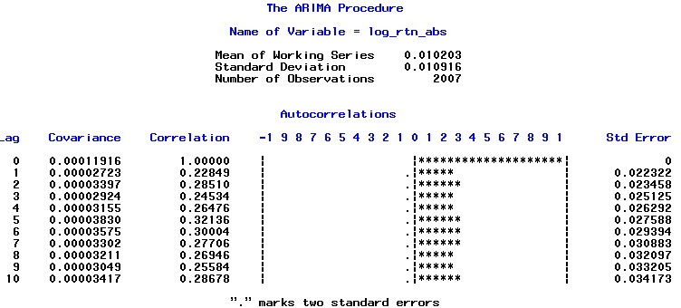

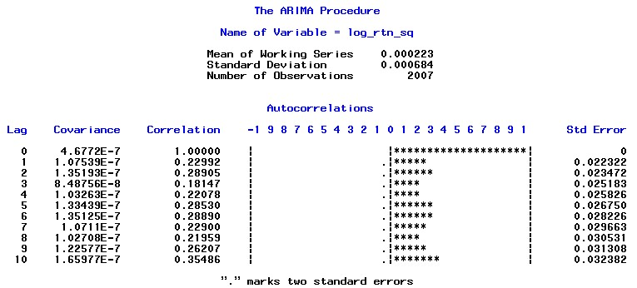

**4. Analyze the PACF of the squared log returns, and describe patterns.**

ANSWER:

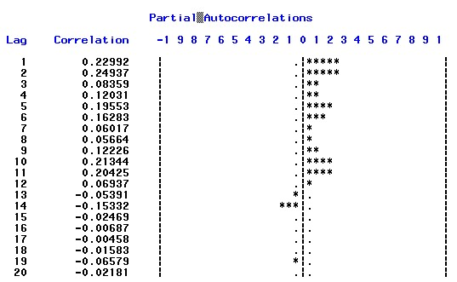

The PACF behaves significant going on to lag 14.

PACF shows significant correlation for first three lags, indicating that if we want to fit a AR(3).

**5. Fit a GARCH(1,1) model for the NDX log returns using a normal distribution for the innovations. Perform model checking and write down the fitted model.**

ANSWER:

The residual normality test shows, from the below pics, that the residuals are close to normal distribution. So, it is not a bad model!

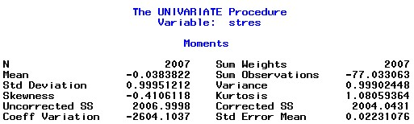

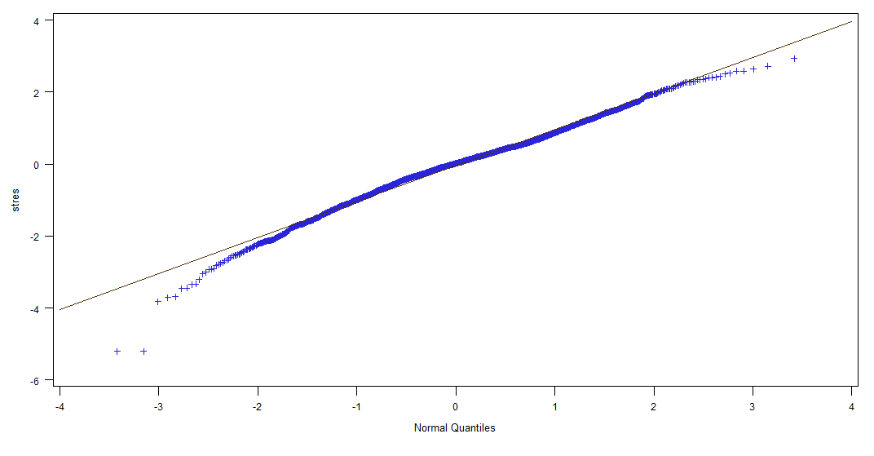

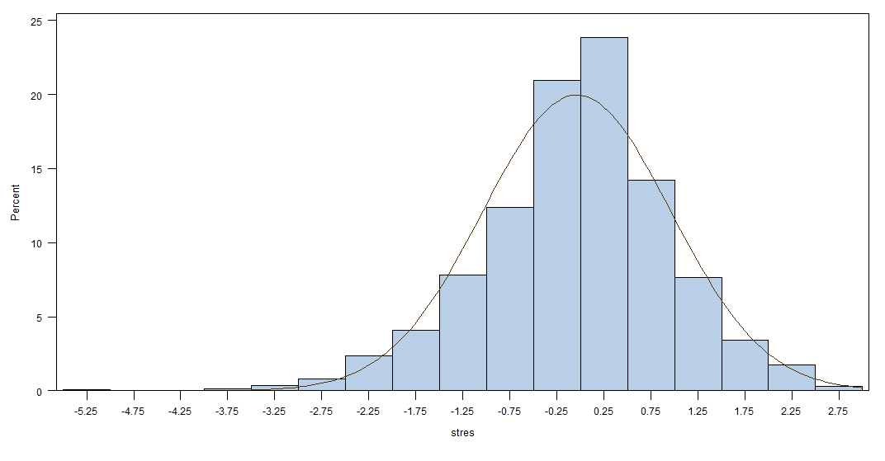

The L-B test for residual is below, the 1st is for standard residuals, the 2nd is for squared standard residuals. They show that the squared standard residuals are not white noise, so the volatility model maybe not adequate.

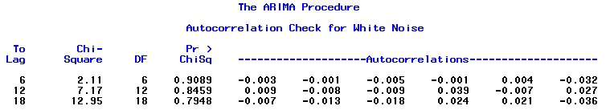

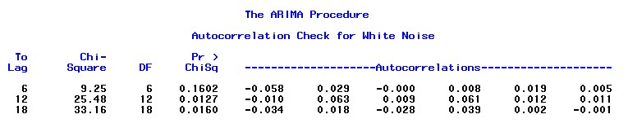

the model is 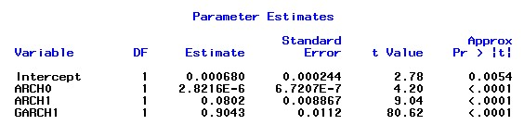

rt = 0.000680+at

σt2 = 2.82e-6+0.0802at-12+0.9043at-22

constraints: 0.08>0, 0.90<1.0, 0.08+0.90 <1.0

**6. Find a GARCH(1,1) model for the NDX log returns using a the t-distribution for the innovations. Perform model checking and write down the fitted model.**

ANSWER:

Residuals analysis:

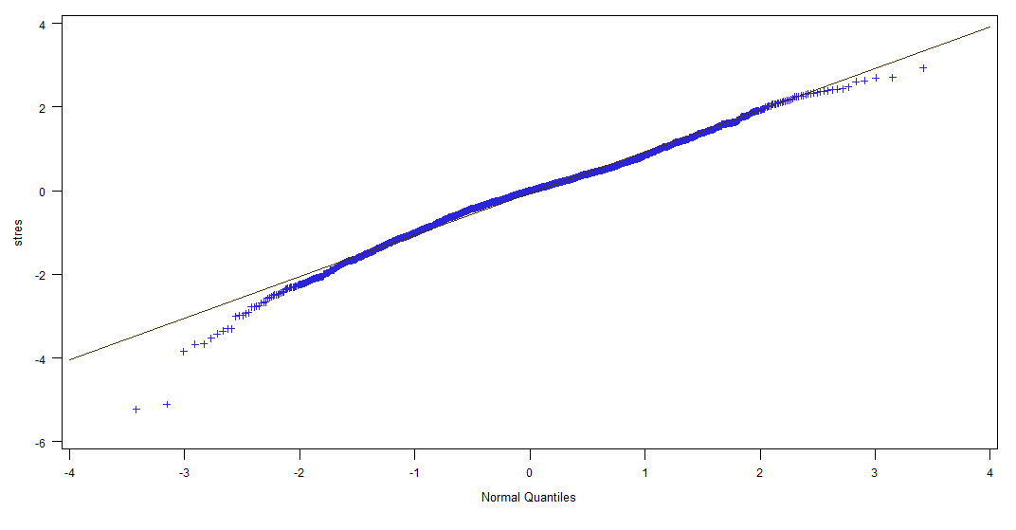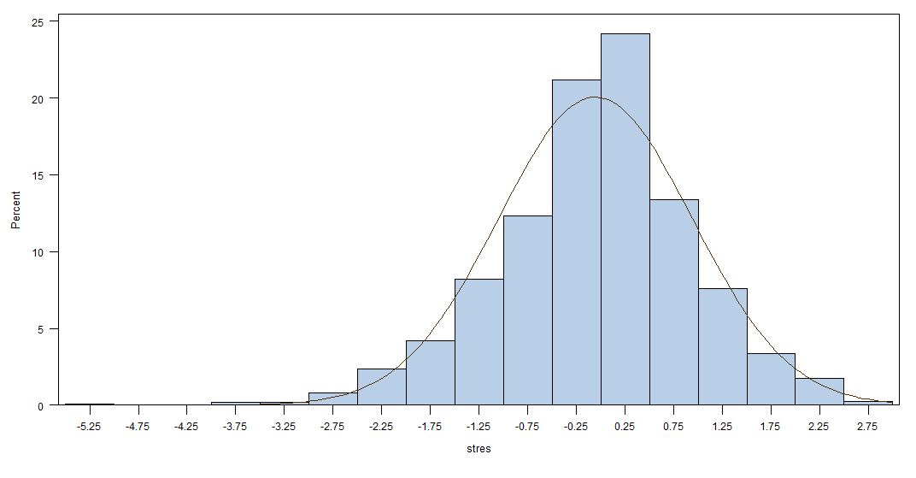

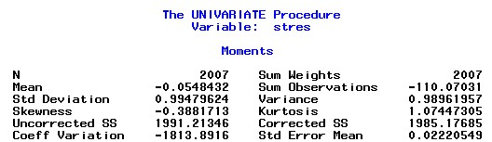

The residual analysis largely shows the same result as the one under normal distribution assumption, except that the kurtosis and skewness improve a bit.

White noise test for residuals (1st is stresid, second is squared stdresid)

:

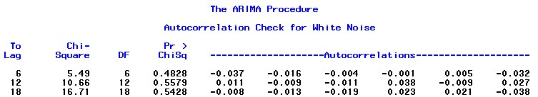

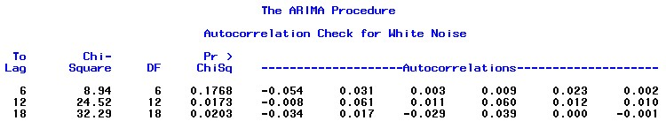

The model:

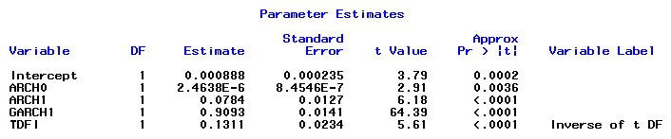

R­t = 0.000888+at

σt2 = 2.464e-6+0.0784at-12+0.9093at-22

constraints: 0.0784>0, 0.9093<1.0, 0.078+0.90 <1.0

**7. What model provides the best fit for the data? Explain.**

ANSWER:

Either model performs not very well, since the squared standard residuals are not white noise, suggested by L-B test on residuals of the fitted models. Besides this flaw, both models look relatively the same. So my choice is either one.

**8. Use the selected model to compute up to 7 step-ahead forecasts of the simple returns and its volatility.**

ANSWER:

Since I prefer either one of the models, here to illustrate the forecasts, I will use the one that assume innovation is under normal distribution.

C:\Users\felix\Dropbox\courses\csc 425\homework_4\12345.jpg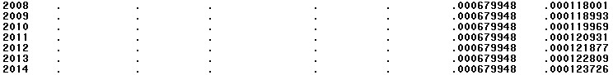

pred\_simp is the simple return forecasts.

v\_simp is the simple volatility.